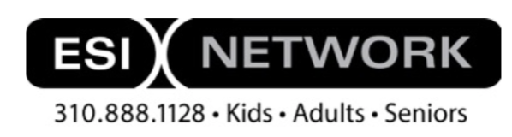
Isabella J. Salazar

Height: 5’2” Hair: Dark Brown Eyes: Dark Brown Non Union
Film:
Test Drive Angel Sam Tahhan
Puma Holiday Commercial Daughter Puma
Deadly Promises Megan Tolian Productions
Invisible World Andrea David Tybor
Moon Sign Diana CU Film School
Teleprompter Maria Tobacco Second Chance
Print:
Cover NEFE Starring National Endowment for Financial Education
Theater:
Addams Family Wednesday SkyView Academy
Drowsy Chaperone Kitty SkyView Academy
Footloose Featured Dancer; Chorus SkyView Academy
White Christmas Featured Dancer; Chorus SkyView Academy
As You Like It Corin Town Hall Arts Center
Training:
Acting 1 Anne Penner University of Denver
Voice Lessons Julie Schnell Highlands Ranch, CO
Teen and Young Adult Master Class Zak Barnett Studios Los Angeles, CA
Book a Co-Star Intensive Scott Sedita Los Angeles, CA
Audition Technique Tess Christiansen Burbank, CA
Screen Teens Diane Christiansen Burbank, CA
Comedy Intensive Scott Sedita Los Angeles, CA
Theater I & II Julie Schnell SkyView Academy
Private Coaching Emotions Joanna Sanchez Los Angeles, CA
Private Coaching Auditions Diane Christiansen Burbank, CA
Private Coaching Sides Damon Pfaff Santa Monica, CA
On Camera, Cold Read, Scripts, Improv Su Coffey Hollywood Showcase, CO
Intro to Cha Cha, Swing, & Foxtrot Bobbie Briceno Colorado Dancesport
Intro to Shakespeare’s Iambic Pentameter Jefferson County Schools Denver, CO
Improv Weekend Jefferson County Schools Denver, CO
Improv Anthony Bruno Falcon Bluffs MS
Summer Intensive Jazz/Lyrical/Ballet, Hip Hop Xtreme Dance Force
Awards:
Best Young Actress Best Actor Award 2020
Recognition: Supporting Actress IndieFEST Film Awards 2020
Best Young Actress New York International Film Festival 2020
Best Supporting Actress Queen Palm International Film Festival 2020
Best Supporting Actress American Golden Picture Int. Film Festival 2020
Best Supporting Actress Mindfield Film Festival Albuquerque 2020
Best Young Actress Oniros Film Awards 2020
Recognition: Supporting Actress Accolade Competition 2020
Best Duo LA Film Awards 2020
Best Ensemble LA Film Awards 2020
Skills
Volleyball, Downhill Snow Skiing, SUP (Paddle Boarding), Cycling, Softball, Soccer, Rollerblading, Ice Skating, Ballet, Jazz, Lyrical, Contemporary, Hip Hop, Ballroom Dancing, Gymnastics Skills, Trampoline Skills, Vocalist, Understands Spanish, Athletic Skills, Freshman Lettered In Choir, New York Accent

